
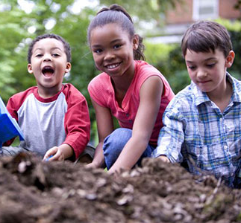
Early Years Foundation Stage
Characteristics of effective learning

Children learn and develop through play in the Early Years displaying the ‘Characteristics of Effective Learning’. These are playing and exploring, active learning and creating and thinking critically.

Children will play for long periods inside and outside, during this time practitioners will carefully facilitate their play to move their development onto the next stage. They will observe children and plan their next steps, often in the moment. The EYFS recommends a balance of child-initiated learning and adult-initiated learning therefore there will be times when adults initiate learning in small groups for example during story time or circle time.

There are 7 Areas of Learning

These 7 areas are used to plan your child’s learning and activities.

Prime Areas:
Personal, Social and Emotional Development
Communication and Language
Physical Development

Specific Areas:
Literacy
Maths
Art & Design
Understanding the World

The professionals teaching and supporting your child will make sure that the activities are suited to your child’s unique needs and teach children holistically. Importantly children will have long periods of uninterrupted play. Research has shown this develops creativity, imagination, problem solving and a concentration span that they take with them to adulthood.
Key Person
Is your main point of contact within the setting and helps your child to become settled, happy and safe. They are responsible for your child’s care, development and learning. Your child’s key person takes a careful note of your child’s progress, sharing this with you and they will give you ideas as to how to help your child at home.

Progress Checks
Providers will track your child’s progress through their stages of development from birth to the end of the reception year, this doesn’t have to be recorded but it may be. This should be shared and passed on between providers caring for your child (if they more from childminder to pre-school for example).

Your child’s progress will be reviewed formally when they’re between 2 and 3 by an early year’s practitioner and when they reach the end of reception by their teacher. The assessment is based on classroom observation, your child won’t be tested. It uses the early learning goals, which can be found in the Early Years Framework.

An important part of the EYFS Profile is your knowledge about your child’s learning and development, so do let your child’s class teacher know about what your child does with you: such as how confident your child is in writing their name, reading and talking about a favourite book, speaking to people your child is not so familiar with or their understanding of numbers. All of the information collected is used to judge how your child is doing in the 7 areas of learning and development.
There are 7 key features of effective practice
1. Providing the best for every child
2. Providing high quality care
3. Developing and delivering the best curriculum for the children in the setting
4. Developing a pedagogy by continuous professional development
5. Using assessment
6. Ensuring children learn self-regulation and executive function
7. Have effective partnerships with parents

The Early Years Foundation Stage (EYFS) sets the standards for the learning, development and care of children from birth to 5 years old. All schools and Ofsted-registered early years providers must follow the EYFS, including childminders, nannies, after school care, preschools, nurseries and school reception classes. The Early Years Foundation Stage (EYFS) Framework is the core document for all professionals working in the foundation years. It supports an integrated approach to early learning and care. It gives all professionals a set of common principles and commitments to deliver quality early education and childcare experiences to all children.

