**Tips for supporting children with difficulties reading:**

The tips outlined below for supporting children which find reading difficult are in addition to the best practice in supporting reading generally. See:

<ps91x.com/news/2017/10/28/tips-on-supporting-readers-at-home>

1. **Create a stress-free environment. As well as creating a routine and a comfortable environment,** foster a relaxing environment by removing any deadlines, time-limits or assessment related goals and just focusing on reading for enjoyment. When students are enjoying a book, anxiety and stress are reduced and fluency is enhanced.
2. **Make use of a variety of books and materials (including apps – see number 9).**For someone with difficulty reading it can be even more of a struggle to practice with material that is not of interest to them. Sometimes all it takes is getting readers excited about a topic to help them lose themselves in the activity. Try chapter books, comics and poems. Even picture books can work as long as the student doesn’t perceive the material as being below their level. Experiment with texts of different lengths starting with shorter material and gradually working up to longer pieces.  Where comprehension is concerned the emphasis is on the quality of the student’s reading, not the quantity of pages or speed at which they read them.
3. **Encourage children to use a ruler or finger to follow along.**Decoding is easier when students don’t lose their place as they move across a page. It’s up to the individual student how they go about this. Some may want to use a pen or pencil, others a piece of paper that they move down to cover the bottom of the page and stay focused on the sentence in front of them. This is also a good strategy for readers with ADHD because it involves a kinaesthetic element.
4. **Pre-teach vocabulary.**Prime the words your child is going to see in a text and practice reading them in isolation first. If the title of the book is “the owl who was scared of the dark’, the words ‘owl’, ‘scared’ and ‘dark’ are going to occur several times in the book. Being confident on these words and identifying these words by ‘sight’ before you start will result in children being more confident whilst reading the book.
5. **Read the same thing several times.**When you’re trying to improve fluency, it helps to see the same text multiple times. Each reading becomes easier and motivation goes up as students experience enhanced fluency thanks to repeat exposure to words and phrases. It can also help when it comes to developing comprehension skills as readers have more opportunities to notice contextual cues. This does mean that you have to read the same page several times the same night.
6. **Practice reading high-frequency** / **sight words.** Some words are more common than others and students who have a hard time with fluency will find it is much easier to read when they are familiar with 90% of the vocabulary in a text. A list of the first 100 high frequency words that are most common in books are at the end of this document. These words can be written on flashcards and your child can practice reading 5 of them a day. These words should be identified by ‘sight’ and read immediately rather than phonetically decoded.
7. **Try different font and text sizes.**If there’s a visual impairment that is causing some of the difficulty, reading larger text or text printed on colour tinted paper can sometimes make things easier. If you are reading on the computer, there is often the “accessibility” option to read the page out loud (although this option is normally well hidden!). You can also change the page colour, font and size combinations. Sans Serif fonts are easier to discern letters and decoding language.
8. **Guide students to help them establish a steady pace.**One of the hallmarks of fluent reading is establishing a consistent rhythm and pace that guides students through a text. This doesn’t need to be fast and in the beginning new readers should have the option to start slow and increase their pace as they become more comfortable. Encourage them to take a breath at punctuation.
9. **There are many interactive apps to make reading fun**, including apps to help with identifying phonics. This fun, interactive repetition of the work carried out in reception and Year 1 will support all learners but the multisensory nature of these apps will help children showing dyslexic tendencies, e.g. Jolly Phonics, How to teach your monster to read (the app is paid for but it is free on the computer).

Apps like CBeebies Storytime App (for younger children) and other apps, e.g. English stories, allow you to have stories read to you (no more having to buy books or go to the library!)

List of apps for Apple devices: <https://www.onlinecollegecourses.com/2012/09/16/50-best-ipad-apps-for-reading-disabilities/>

Once children have mastered these skills, they will then be able to work on their comprehension skills through VIPERS which the class teachers will be talking about.

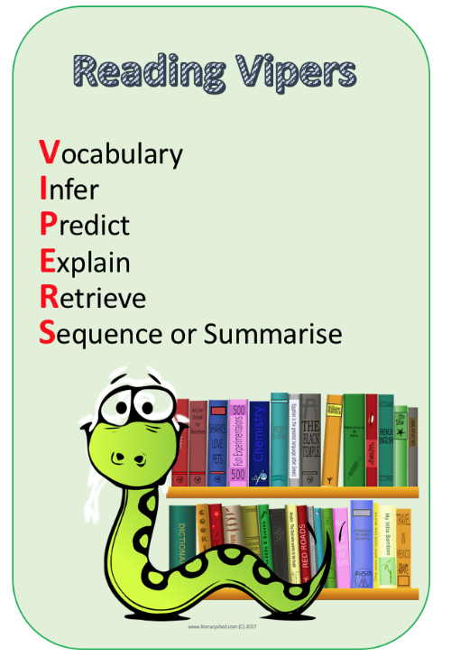

**The most important consideration is to reduce anxiety when reading. Start with small chunks of reading and build gently.**