

POLICY ON THE USE OF THE SCHOOL MINIBUS
INCLUDING BEHAVIOUR

Category: | Finance | Non-statutory
Last Modified: | March 2016
Review Date: | March 2021
Reviewed by: | Finance
Approved by: | Governing Body
Related Policies: | Pupil Discipline and Bullying
When monitoring and reviewing we ensure compliance with the school's Race, Equal Opportunities and Disability Equality Scheme

INTRODUCTION

The school owns a minibus which is used principally to provide free transport to and from school for pupils who live in the catchment area (pupils who attend the school and live outside the catchment area can use the minibus to travel to and from the school, but will be charged at the prevailing termly rate), see appendix C. The minibus is also used for school trips and visits.

DRIVERS

- All drivers must have passed the local authority driving test before driving the vehicle.

- All drivers will accept responsibility for the safety of their passengers and other road-users through abiding by the rules in appendix A.

- One driver (normally the person who drives the vehicle on a regular basis) will be designated “Main Driver”. Rules and responsibilities for all drivers are detailed in Appendix A. It is the responsibility of the Headteacher to ensure that the vehicle is properly maintained.

- All drivers, including third party, will be registered with the insurer, having provided a copy of their driver’s licence.

VEHICLE

- The vehicle is comprehensively insured with an insurance company.

- The vehicle will be properly maintained through regular weekly inspections, routine servicing as per the manufacturer’s recommended schedule, MOTs and ad hoc servicing where necessary.

PASSENGERS

- All passengers are expected to behave themselves whilst being transported (see Appendix D). In particular they are expected to stay seated whilst the vehicle is in motion and not to distract the driver in any way.
- The minibus can seat a maximum of 16 passengers plus driver. Seat belts are fitted to all seats; passengers and the driver must wear seat belts at all times. It is the legal responsibility of the driver to ensure all passengers wear seatbelts.
- The driver is authorised to refuse to carry any passenger whose behaviour is, in the driver’s opinion, such as to compromise his ability to drive safely.
- Passengers are not permitted to eat or drink on the minibus.

PRACTICE AND PROCEDURES

These are detailed in the attached appendices A and B.

MONITORING AND REVIEW

The designated Committee of the Governing Body monitors this policy every three years. This Committee reports its findings and recommendations to the full Governing Body, as necessary, if the policy needs modification.

APPENDIX A: RULES APPLYING TO ALL DRIVERS

- The roadworthiness of the minibus is the RESPONSIBILITY OF THE DRIVER AT ALL TIMES. This rule applies to third party drivers as well as to the school’s own drivers.

- Any driver who becomes aware of any vehicle malfunction or possible malfunction must fill in the appropriate section of the log sheet and lodge it with the School Office. The driver must not continue to drive the vehicle if he believes or suspects it is unsafe to do so.

- The minibus can seat a maximum of 16 passengers plus driver. Seat belts are fitted to all seats; passengers and the driver must wear seat belts at all times. It is the legal responsibility of the driver to ensure all passengers wear seatbelts.

- The minibus takes diesel. Diesel can be purchased using the Allstar Card in the leather holder kept in the minibus. Drivers should verify that the vehicle has adequate fuel prior to each journey.

- Drivers must drive carefully and safely with absolute regard to the safety and comfort of occupants as well as the limitations of the vehicle. They should also be considerate of other drivers. The minibus is limited to a maximum speed of 62 m.p.h.

- Drivers must not allow passengers’ bad behaviour to compromise the safety of the journey and may refuse to carry anyone whose behaviour they deem does so. Repeated bad behaviour on the vehicle must be reported to the Headteacher.

- The sum of working hours, driving time and pupil supervision on trips should not exceed 9 hours in any one day for any driver. A rest of at least a quarter of an hour after 2 hours driving and 45 minutes after 4½ hours driving is mandatory. Drivers should consider sharing with a support member of staff whenever more than a short trip distance is involved.

- Drivers must be aware of drink/drive legislation and must on no account consume alcohol before driving. The vehicle may be driven only by staff who have been tested and passed as fit to drive through the local authority driver’s test. A list of staff who can drive the minibus is kept in the school office. Staff who wish to drive must inform the office and take the relevant course. Copies of driving licences are kept in the office.

- The minibus has EMERGENCY BREAKDOWN SERVICES cover provided by the insurer. Details of breakdown cover is kept in the minibus. An emergency/touring kit is available from the office and should be taken when longer journeys are involved. Please note that all users of the minibus are requested not to attempt to change the wheels themselves in the event of a puncture, but to call Emergency Breakdown Services.

- Drivers must not use mobile phones whilst driving. The radio or CD should not be used when pupils are on board.

APPENDIX B - MINIBUS LOG SHEET

To be completed:

weekly by the Main Driver, or his Deputy (fill in section A), and

by any driver who becomes aware of a vehicle malfunction during use (fill in section B only)

SECTION A WEEKLY CHECKLIST

Date……………………………………………………………

Mileage...................................................................................

Oil level OK YES/NO COMMENT…………………………………..

Radiator water level OK YES/NO COMMENT…………………………………..

Tyre pressures OK YES/NO COMMENT…………………………………..

Tyre tread depth OK YES/NO COMMENT…………………………………..

All lights functioning correctly YES/NO COMMENT…………………………………..

Fuel gauge level YES/NO COMMENT…………………………………..

W/screen water reservoir topped-up YES/NO COMMENT…………………………………..

First Aid Kit complete YES/NO COMMENT…………………………………..

Fire Extinguisher in place YES/NO COMMENT…………………………………..

Fuel card in leather holder YES/NO COMMENT…………………………………..

Signed …………………………………………………………..

SECTION B FAULT REPORT

To be completed by any driver who becomes aware of a vehicle malfunction during use.

Date……………………………………………………………

Mileage...................................................................................

NATURE OF MALFUNCTION

ACTION TAKEN

Signed.......................................................................................................

Please return this form to the School Office as soon as possible.

Appendix C

To make an application for Free Home to School Transport or to view all the Home to School Transport Policies and related forms
Website/online application: www.westberks.gov. u k I schooltransport

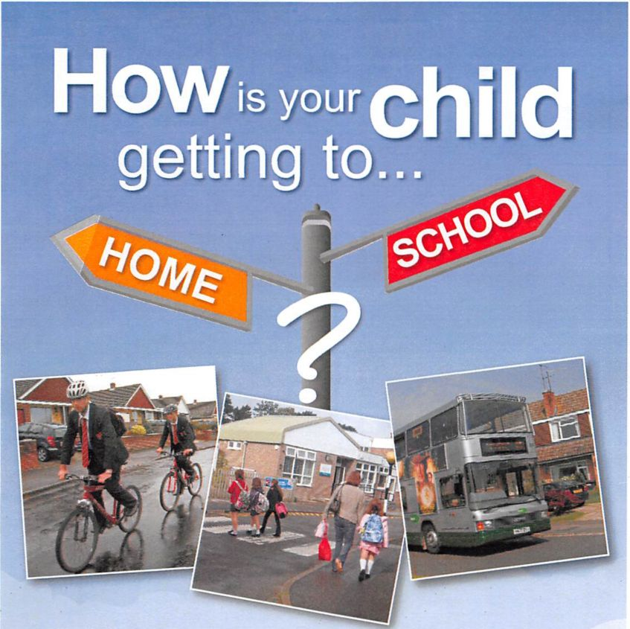
Parents Guide

Are we eligible for help with school transport?
To see if your child is eligible for free Home to School Transport please read the criteria within the Home to School Transport policy for the relevant academic year. This is available on:
www.westberks.gov.uk/schooltransport
The criteria in the policy includes:
- Distance
- Low income families
- Special Educational Needs - mainstream or special school
- Temporary Medical Condition
To make an application for Free Home to School Transport or to view all the Home to School Transport Policies and related forms
- Website/online application: www.westberks.gov. u k I schooltransport
- 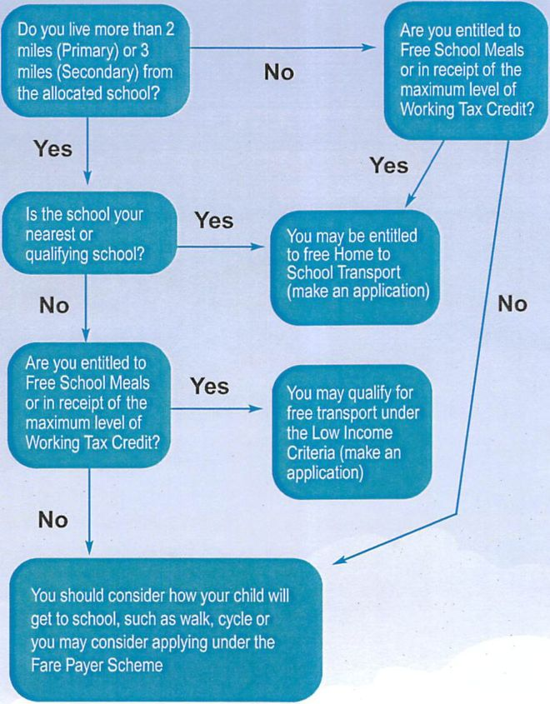
- Eligibility Flowchart
Have you considered how your child will travel to school?
Walk, cycle or catch the bus? The Council supports sustainable and active travel to school, such as walking, scooting or cycling. Supporting these helps to improve children’s health and fitness, make children more aware of their surroundings, and arrive at school more relaxed and ready to learn. Fewer cars outside the school gate helps to reduce congestion on our roads and improves road safety outside schools.
All schools in West Berkshire have School Travel Plans which sets out what the school are trying to do to help and encourage children to walk or cycle to school. Schools are involved in a number of schemes, including walk to school reward scheme Go Kinetic, National standard cycle training (Bikeability) as well as theme days and weeks such as Walk to School Week and Bike Week. If you would like further information request the travel plan from your child’s school or access the website www.westberkshire.gov.uk/ schooltransport
Frequently Asked Questions
We have a large number of frequently asked questions available on the website www.westberks.gov.uk/schooltransport/ faq to help you during and following the application process.

Contacts
To make an application for Free Home to School Transport or to view all the Home to School Transport Policies and related forms
Website/online application: www.westberks.gov. u k I schooltransport
To email a query regarding transport: pupiltransport@westberks.gov.uk
Telephone:
Pupil Transport & Business Development Officer 01635 519777
To Apply for the Farepayer Scheme
Website/online application:
www.westberks.gov.uk/
schooltransport
Telephone queries:
Education Transport Officer 01635 519237 Market Street, Newbury RG14 5LD
For any transport queries, lost passes, bus routes I times etc
Telephone:
Education Transport Officer 01635 519100
Discretionary Fare Paying Transport Scheme
The Council may fill any vacant seats on school buses contracted by the Council for pupils who are not entitled to free home to school transport.
This Scheme is open to school pupils aged 5-16 and post-16 students who are resident in West Berkshire and attend a West Berkshire maintained school or academy. It does not apply to independent schools.
Please refer to the Farepayer Scheme Policy on
www.westberks.gov.uk/schooltransport
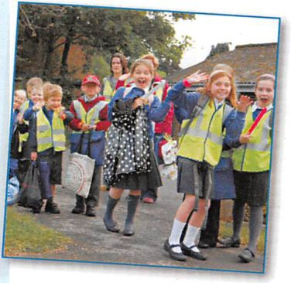
Appendix D

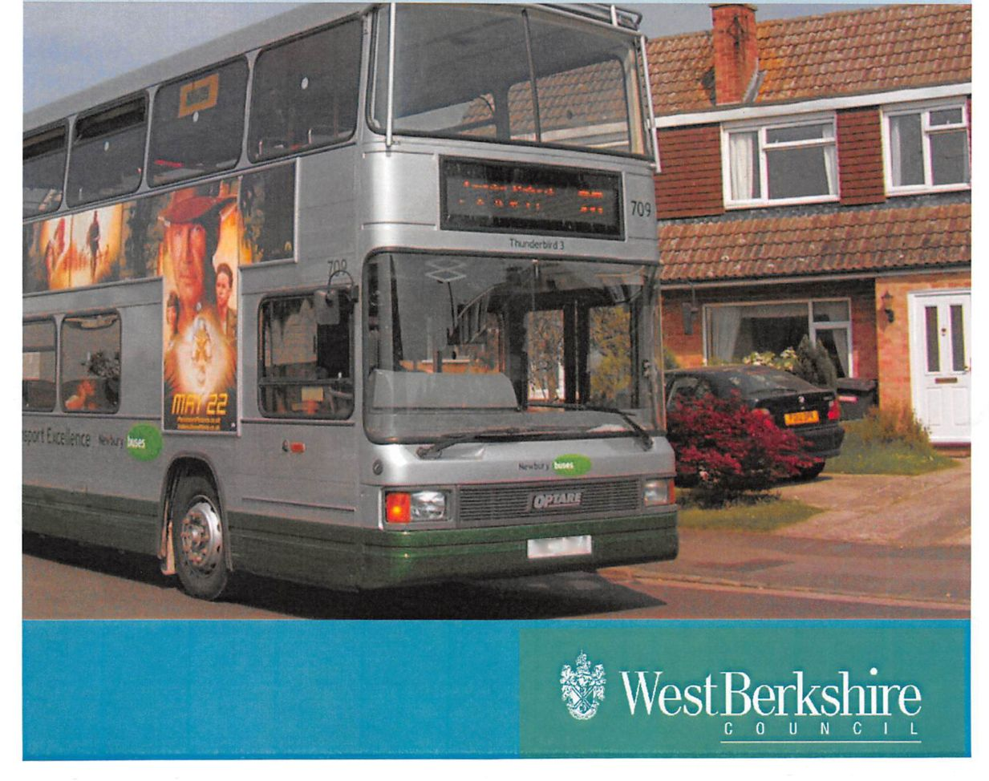
Home to School Transport Behaviour code
Information for parents and schools

Introduction
Young people are entitled to safe travel. Whilst the majority of learners behave well whilst travelling to and from school, there are examples of poor and disruptive behaviour, which is a threat to safety and can have tragic consequences. West Berkshire Council will investigate incidents involving learner travellers to ensure that consistent standards of behaviour, enforcement and sanctions are adopted.
Our approach is to work proactively with learners, their parents and the community to promote positive behaviour. The Behaviour Code promotes safe travel for all learners, by setting out the standards of behaviour required. We hope that by working closely with schools, we can limit the use of sanctions so that they are only applied in the most serious of cases. This will also encourage a more appropriate and considered response to deal with reported incidents.
The Code sets out standards of behaviour expected of a learner when travelling to and from their place of learning. Transport operators and drivers will be familiar with the Code and the procedure to follow if a learner misbehaves.
Learners must comply with the Behaviour Code whilst travelling to and from school. The Behaviour Code links to the school’s behaviour policy and Headteachers will ensure that pupils at their school are aware of and comply with the Behaviour Code. They will be able to take disciplinary action against learners who have breached the Code whilst travelling to and from school or between other schools.
Parents, as well as a learner, need to be aware of the implications if a learner does not follow the Behaviour Code. West Berkshire Council can withdraw an individual's entitlement to transport, or the school can take action against them. In the event that transport is withdrawn from a learner, it is the responsibility of the learner’s parents to arrange suitable transport to and from school.
The Council will work in partnership with the school to make judgements about what is the most appropriate action to take in particular circumstances dependant on the severity of the misbehaviour. The Council and the school may decide that action under the school’s behaviour policy is more appropriate to the incident.

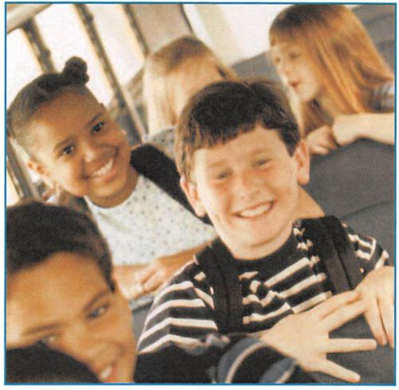
“The Code sets out standards
of behaviour expected of a
learner when travelling to and
from their place of learning. ”

Roles and Responsibilities
Learners
- Must follow the instructions in the Behaviour Code leaflet when travelling to and from school
Parents
- Must ensure that the learner has understood the Behaviour Code
- Must accept responsibility for encouraging good behaviour and ensuring their children comply with the Code
- Should be aware of the implications of breaches of the Code and the effect this can have on their child’s right to the provision of transport to and from school
- Should co-operate with the school, transport operators and the Council to enforce the Code
- Will be responsible for the learner’s continued attendance at school if transport is withdrawn
- Must ensure that pupils are at the boarding point five minutes before transport is due and that young children are looked after until transport arrives
- Must ensure that young pupils are met when the transport returns from school
- Are responsible for their children before boarding and after alighting from school transport
What are Schools responsible for
- Should publicise and raise awareness of the importance of good behaviour and the consequences of failing to comply with the Behaviour Code
- Should incorporate the Code into their existing behaviour policy
- Should alert West Berkshire Council to alleged breaches of the Code and provide information and assistance that is reasonably required
- Should make learners aware of an appropriate person to talk to within the school about incidents of bad behaviour whilst travelling from home to their school
- Should work in partnership with West Berkshire Council in the handling of disciplinary action for breaches of the Code, including involvement in the interviewing of learners as part of any investigation
- Should ensure that contact details of designated staff responsible for handling all matters relating to the Code are made available to transport operators, learners and the Council
- Should report suspected criminal offences or child protection matters to the relevant authority
The Council
- Should publicise and raise awareness of the importance of good behaviour and the consequences of failing to comply with the Behaviour Code
- Should ensure that contact details of designated staff responsible for handling all matters relating to the Code are published on its website and in all the relevant correspondence with schools and transport operators
- Should train relevant staff in the content and application of the Code
- Should investigate suspected breaches of the Code where appropriate
- Should ensure that a record is kept of all reported incidents. All records of incidents should be copied to the relevant school
- Should regularly review and monitor the contractual arrangements entered into with transport operators to ensure that they are aware of the Code and their responsibilities under the Code
- Should work in partnership with the school in the handling of disciplinary action for breaches of the Code
- Should report suspected criminal offences or child protection matters to the relevant authority
- Should ensure that the use of sanctions under the Code is consistent

Breaches of the Behaviour Code
Breaches of the Behaviour Code will be investigated, and if proven, will be dealt with as follows:
Category 3 - Unacceptable behaviour
This includes, but is not limited to, minor incidents that may be irritating, unpleasant or offensive behaviour, but not dangerous. For example, eating or drinking (except where permission has been granted), shouting, littering, failure to show a travel pass (where appropriate) and rudeness.
Depending on any previous incidents that the individual may have been involved in, incidents in this category should be dealt with as follows:
- First offence: the learner should receive a verbal warning from school and the Council should keep a record of the incident.
- Second offence - the Council should write to the learner’s parents notifying them of the breaches of the Code and the consequences of continued unacceptable behaviour
- Third offence or more - the Council should consider the withdrawal of learner transport
Category 2 - Dangerous behaviour
This includes, but is not limited to, where there may be the threat of physical danger to individuals. For example, harassing and bullying other passengers, verbally threatening the driver, pushing and shoving when boarding and exiting the bus, spitting, smoking and distracting the driver.
Depending on any previous incidents that the individual may have been involved in, incidents in this category should be dealt with as follows:
- First offence - As a minimum, the Council should write to the learner’s parents notifying them of the breach of the Code and the consequences of continued unacceptable behaviour. The Council may decide that the withdrawal of transport is more appropriate
- Second offence - the Council should consider the withdrawal of learner transport
Category I - Highly dangerous, destructive or life-threatening behaviour
This includes, but is not limited to, behaviours considered very dangerous to individuals and/or destructive, for example interfering with the driving controls or emergency doors, assaulting the driver, pushing others through doors or windows, and interfering with safety equipment.
The Council will investigate the incident and withdraw learner transport for an appropriate period of time.
It is possible that the police will be involved in these instances.
Withdrawal of transport
Before a decision to withdraw travel arrangements is made, the learner and the parents of the learner will be given the opportunity to make representations to the Council. Representations must be in writing and within a time limit specified by the Council. The Council will consult with the relevant school about the decision to withdraw travel arrangements.
There is no statutory appeals process for the withdrawal of transport by the Council. However, the Council’s complaints procedure is available to learners and parents.

