**Guidance on sleep**

This is the first in a series of guides we have written designed to provide useful strategies in a range of common issues that children (and adults) experience.

Sleep is important element for cognitive development in children and is highly correlated to errors in adults such as traffic accidents.

**How much is enough sleep?**

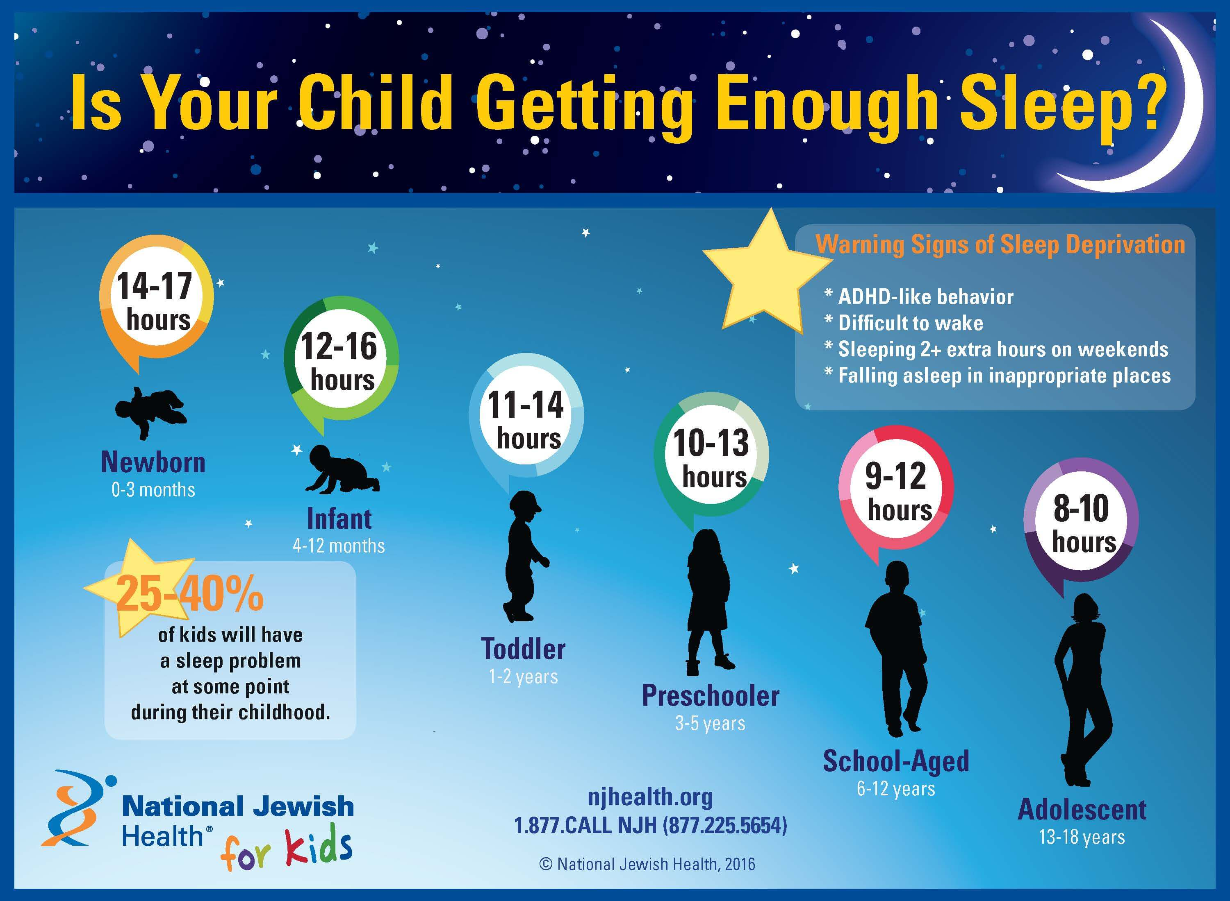

**Top tips:**

Although many of these tips are common knowledge, there may be a few hidden gems that you may wish to try if sleep is an issue for your child, or indeed evades you!

Exercise: Having enough exercise during the day (just running around at lunch in school may not be enough) is important to ensure the body is physically tired. However, avoid exercise just before bedtime as it stimulates the body.

Warm baths: Having a warm bath before bed relaxes the body and then if the bedroom is slightly cooler (open the windows in the bedroom during bathtime), this sends signals to the brain that it is night-time and time for sleep.

Eating and drinking: Avoid having a large meal too late. Although having a large meal makes you feel sleepy, studies have shown that the body is more likely to store these calories as fat, thus is not the healthiest. A snack and small (not too large to avoid bedwetting) milky-drink can create the same sleepiness effect. Certain foods are suggested to promote sleep, although the scientific evidence in humans is sometimes difficult to demonstrate: almonds, kiwis, chamomile tea.

Environment: It is really important that the bedroom environment is as quiet and dark as possible, although young children do usually like having a small night light. The light and noise from devices such as mobile phones and TVs is not suitable and should not be in the room.

Relaxation / other activities: It is important to be unwinding at least 45 minutes to an hour before bed (not doing homework, watching a stimulating TV programme, playing computer games, running around etc). Part of this might be having a bath and doing other relaxing activities. Reading a book and mindfulness (which your child has been taught in school) helps the brain to unwind and feel sleepy.

Routine: Children like a routine and a set bed-time (even though they will challenge and push the boundaries). If it is working, stick to it. If after half an hour, sleep is not happening, instead of worrying about sleeping, the best thing to do is to get up and do a relaxing activity (above) for 20 minutes before going back to bed.

For further information these are some useful websites:

<https://www.moodjuice.scot.nhs.uk/sleepproblems.asp>

<https://youngminds.org.uk/find-help/feelings-and-symptoms/sleep-problems/>